ALR Trends and Insights in the 2025 Census Report
Q3, 2025
———————————
It has been a busy spring and summer for many of us. For those who may have missed it, the state released the results of their Annual Census Report (formerly the Annual Aggregate Data Report). This report summarizes the data submitted by every assisted living community in the state, providing important information that helps us benchmark how we are doing as a sector and how our sector is growing, and provides other metrics that highlight the health and wellness of assisted living in Massachusetts. I’m pleased to again be summarizing some takeaways for our members and highlighting a few interesting data points. I hope you find the following summary useful and insightful.
You can read the full 2025 Census Report (formerly Aggregate Data Report) here. This annual report provides many useful data points that may be of interest to you and other leaders of your community. It collects information on organizational leadership turnover, resident demographics, services and ADLs (assistance with activities of daily living) departures, fees, and resident safety from all certified assisted living residences in the state. This year, all 273 certified assisted living providers operating at the end of 2024 participated in this report.
Leadership turnover continues to improve in the assisted living sector, especially in the role of the Executive Director. In 2024, 77% of communities reported no turnover in the Executive Director position, compared to 69% just two years ago (see chart below). Turnover in the role of the Resident Care Director increased slightly in 2024, though the change does not seem significant compared to more dramatic changes on this metric in the years prior.

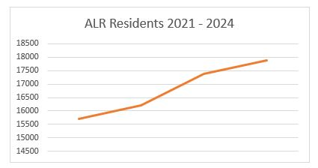
Similar to last year, more units were added that were special care units than traditional units in 2024. Prior to last year, the number of new traditional units added were higher than the number of special care units, which may indicate a trend in the preference of developing special care units over traditional units. However, the total number of special care units continues to only make up about a third of all assisted living units available in the state.
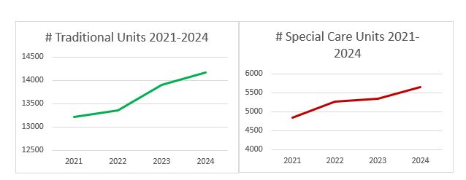
Median occupancy rates did not see much of a change between 2023 and 2024. As of December 31, 2023, the median occupancy rate for providers was 90%, compared to 89% at the end of 2024. The total number of residents did grow in 2024, however, there is a noticeable decline in the rate of increase in total assisted living residents in our state compared to the year prior. There was an increase of more than 1,100 residents in assisted living between 2022 and 2023, but there was only an increase of less than 500 residents in assisted living between 2023 and 2024.
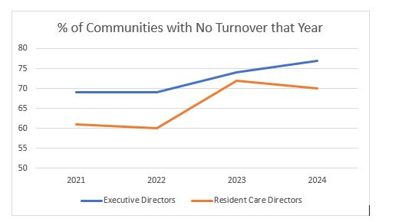
Costs and fees for assisted living continue to rise between 2023 and 2024. The highest reported monthly cost for traditional assisted living decreased from $22,320 reported in 2023, to $20,850 reported in 2024. The highest reported monthly cost for special care also slightly decreased, though not as dramatically ($22,320 in 2023 compared to $22,215 in 2024). The median lowest cost for traditional assisted living in 2024 was $4,228 per month, the median highest cost was $9,225 per month. The median lowest cost for special care in 2024 was $7,218 per month, the median highest cost was $10,886. Last year, I reported that the median costs for special care units had increased more dramatically than the costs for traditional units from 2022-2023. However, the opposite is true this year, with the median costs for traditional units increasing more dramatically than the increased median costs for special care from 2023-2024.
15% of communities reported offering basic health services to residents, either themselves or through a third-party contracted provider. New to the report this year, 43% of communities reported using contract providers for roles such as Personal Care Attendants and Licenses Nurses.
Participation in government assistance programs and dual-eligible health plans remains consistent in usage from year to year. Only about 11% of all assisted living residents participated in one of the following in 2024: Senior Care Options (SCO), Program for All-Inclusive Care of the Elderly (PACE), One Care, Group Adult Foster Care (GAFC), Section 8 Housing, or the MA Rental Voucher Program (MRVP).
There are many additional details, data points, and information about the assisted living sector in Massachusetts provided in the full 2025 Census Report. Dig into the details and see how your community compares to what’s reported across the state in assisted living. You can review reports from prior years here.
Please keep in mind that every certified assisted living residence in the state is required to submit this data to the Executive Office of Aging and Independence (AGE) each year. The data for the 2024 Annual report was collected in February 2025. The Massachusetts Assisted Living Association assists in helping AGE with this collection by reaching out to members to remind them to submit their community data each year by the deadline.
Thank you to everyone who provided data for this useful report! We hope you find the information to be valuable to your efforts. Please reach out to Christina Broughton at cbroughton@mass-ala.org with any questions about this summary or for a link to the full report.

Check It Out: What’s Going-on in Assisted Living!
We’re always keeping an eye out for any news and updates about our members and the broader assisted living community in our state. Check out our members in the news and what’s going on!
On July 30, the Boston Globe featured Cohen Florence Levine Estates of Chelsea, and an outing with residents at Revere Beach. It was a great article showcasing a fun day at the beach for residents and staff alike. Featured in the article is the 2025 Mass-ALA Resident Spirit Award Winner, Charlie Kanter, who at 100 years old explains that he attends the outing every year to support the staff who organize it. You can read the full article on the Boston Globe’s website here.

Welcome New Members
Welcome to our newest assisted living members! We are pleased to welcome everyone at the following communities into the network, who share our passion for advancing and supporting assisted living in Massachusetts.
Mason Wright Assisted Living of Springfield
Please join me in welcoming our newest assisted living members!
Welcome to our newest business partners! Our business partners provide a wide range of services and products to help assisted living communities in areas such as care management and operational support, payroll and HR solutions, and commercial cleaning services.
Bala Consulting Engineers
Clear Guidance
Ecologic Entomology
FOX Rehabilitation
KMB Consulting LLC
Red Ball Promotions
The Junk Removers, Inc.
Tradition Energy
Please join me in welcoming our newest business partners!
Member Spotlights
Assisted Living Provider Spotlight: Prospect House
At Prospect House, we believe home should feel warm, welcoming, and full of life. Comfort meets compassionate care in a nurturing environment where residents enjoy personalized services, engaging daily activities, and 24/7 nursing. From our welcoming portico and gracious foyer to our cozy lounges and outdoor bocce court, Prospect House is designed with comfort and community in mind. Whether it’s a fitness class, movie night, or group outing, there’s always something to look forward to. Visit our Facebook page to see how much fun our residents are having!
At Prospect House, we combine modern living with heartfelt care—giving residents the support they need and the lifestyle they deserve.
Learn more about Prospect House of Revere here: https://prospecthouseal.com/

Business Partner Member Spotlight: HPSI Purchasing Services
With comprehensive purchasing programs, a suite of solutions and Menu Services, HPSI works to ensure each member is led down a path toward more efficient and effective operations. Members gain freedom to choose and customize purchases of quality products that drive the best value for their business.
Dining Services (F&B) – Medical Supplies & Equipment – Capital Equipment – Housekeeping / Chemicals – Linens – Maintenance, Repair & Operations (Elevator contracts) – Administrative – Ancillary Services – Vehicle contracts
Learn more about HPSI Purchasing Services: https://www.hpsionline.com/

